|  |  |  |  |  |
| --- | --- | --- | --- | --- |
| |  | | --- | |  | |  | |  | |  | |
| Leave Application Portal v1.0  User Manual |
| Amol Modi, Anjana Pradeep, Supratika Banerjee  TE-2 ESDL Miniproject 28/09/2014 |

INTRODUCTION

This manual will assist you to navigate through the system in the shortest time possible. It contains:

* • Details on how to access the leave management system.
* • How to apply for leave.
* • Leave approval flow.
* 1 How to login
* Open your web browser and type: localhost/source.html
* Enter your domain (vault) username and password to login to the system.
* **See the screenshot below**

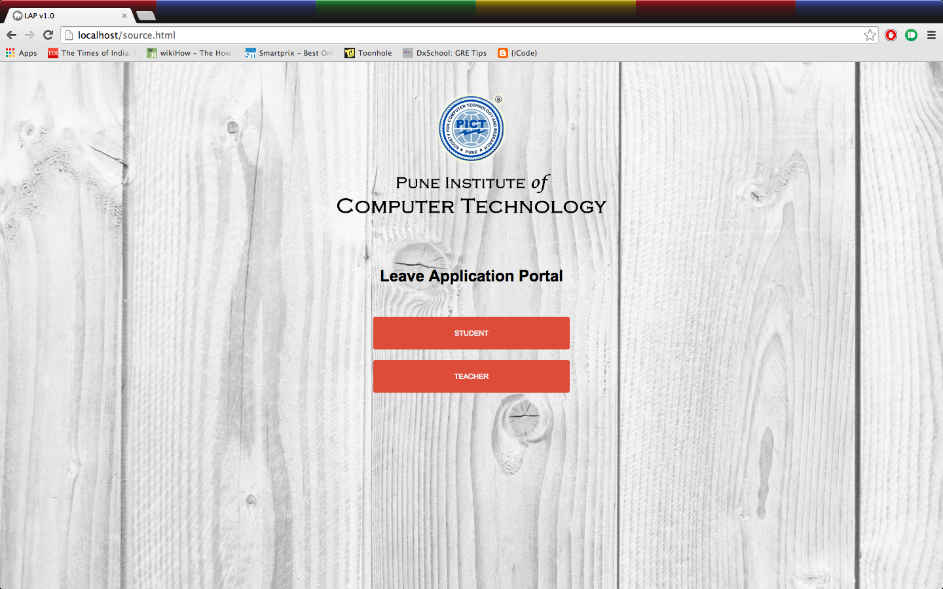

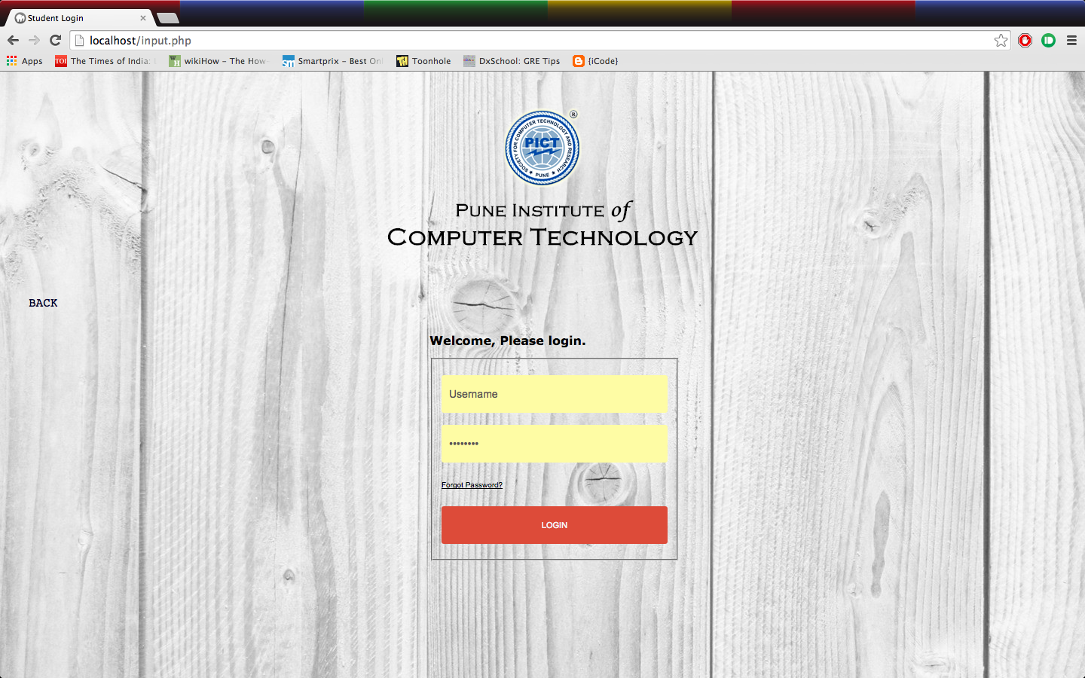

2 How to apply for leave

After logging in you will see the page contains your details.

* **See the screenshot below**

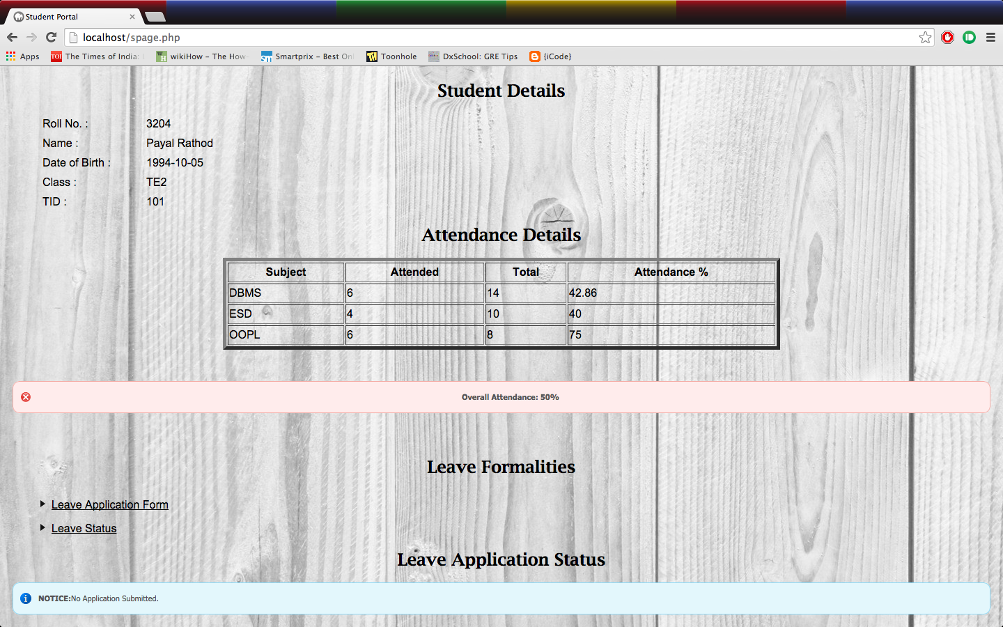

Click on the link Leave Application Form. It will redirect you to the leave form.

Fill in the required fields that include the reason for leave, the number of days, start date and end date. You cannot apply for more than one leave at a time.

* **See the screenshot below**

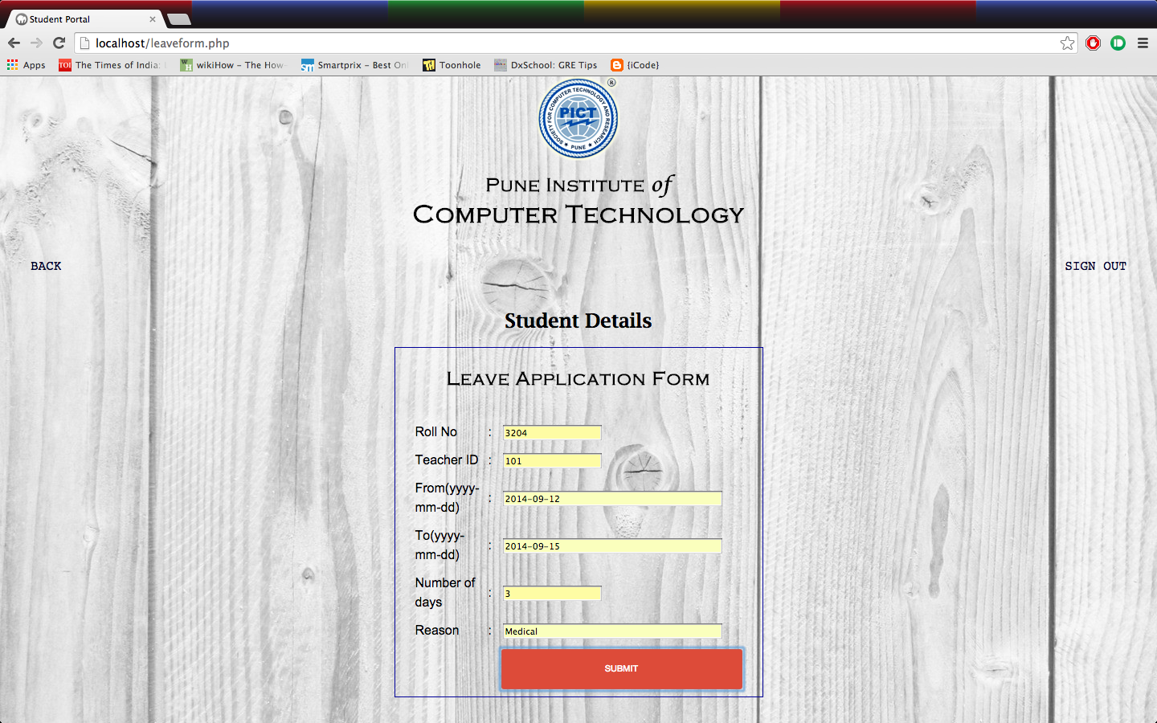

If your leave form has been successfully submitted you will see the following page otherwise you will be redirected to an error page displaying the reason for the error.

* **See the screenshot below**



After applying a notification is sent to yourself and the respective teacher.

Log out the application.

3 Teacher Approval

3.1 Teacher Login

* At source page, the teacher can redirect to the teacher login by identifying him/herself as the teacher.
* Enter their domain (vault) username and password to login to the system.
* **See the screenshot below**



After logging in successfully, the Teacher will be greeted with the following page.

* **See the screenshot below**

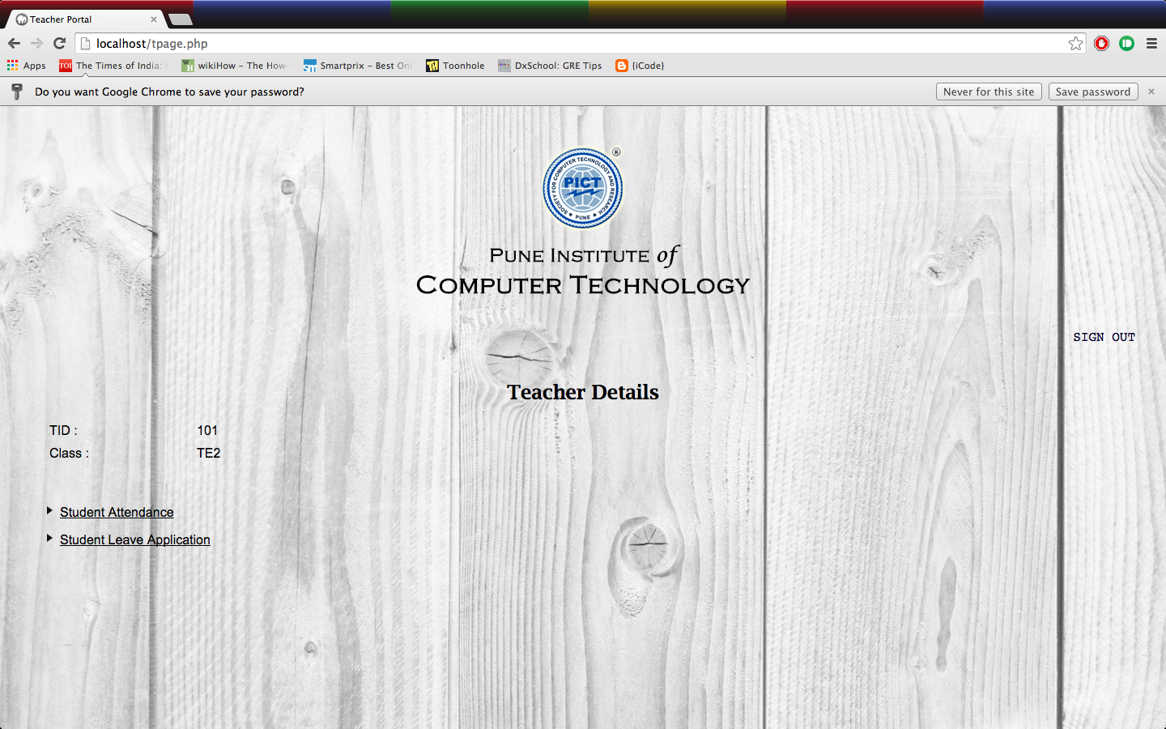

3.2 Attendance Updating

Click on the button Student Attendance to redirect to the page showing the current attendance records of students and update link.

**See the screenshot below**

* 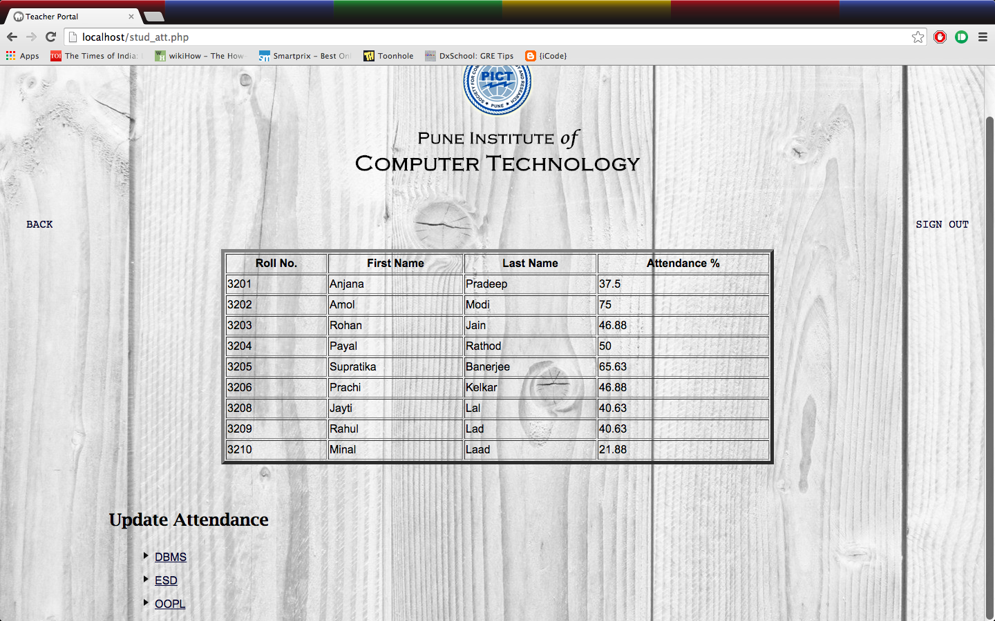

Click on the subject whose attendance has to be updated. To update attendance check the checkbox in front of the students name to mark as attended or leave it unchecked to mark absent and click on submit when done marking.

**See the screenshot below**

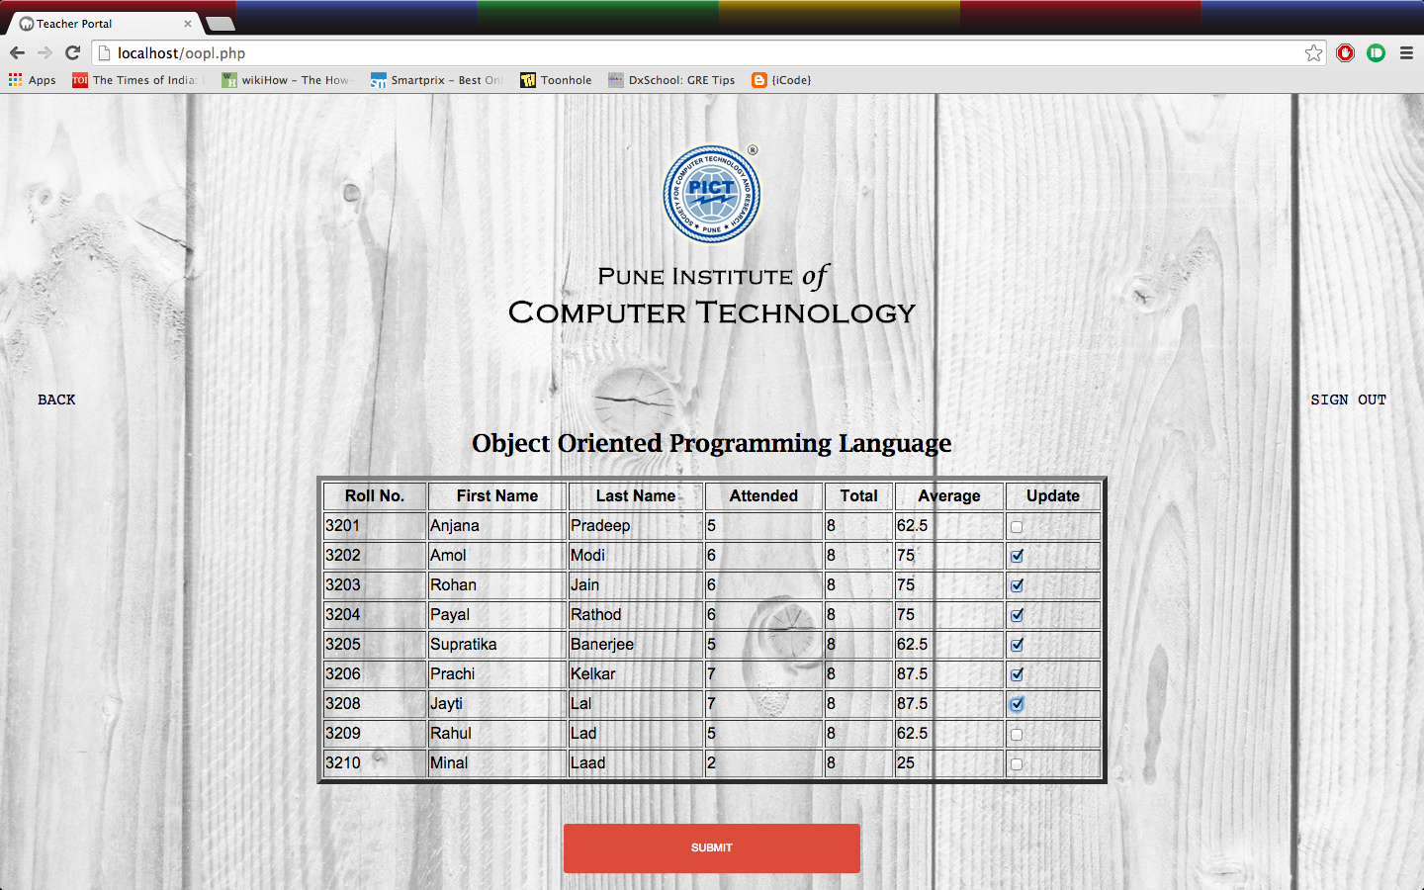

If the attendance has been successfully updated will see the following page.

**See the screenshot below**

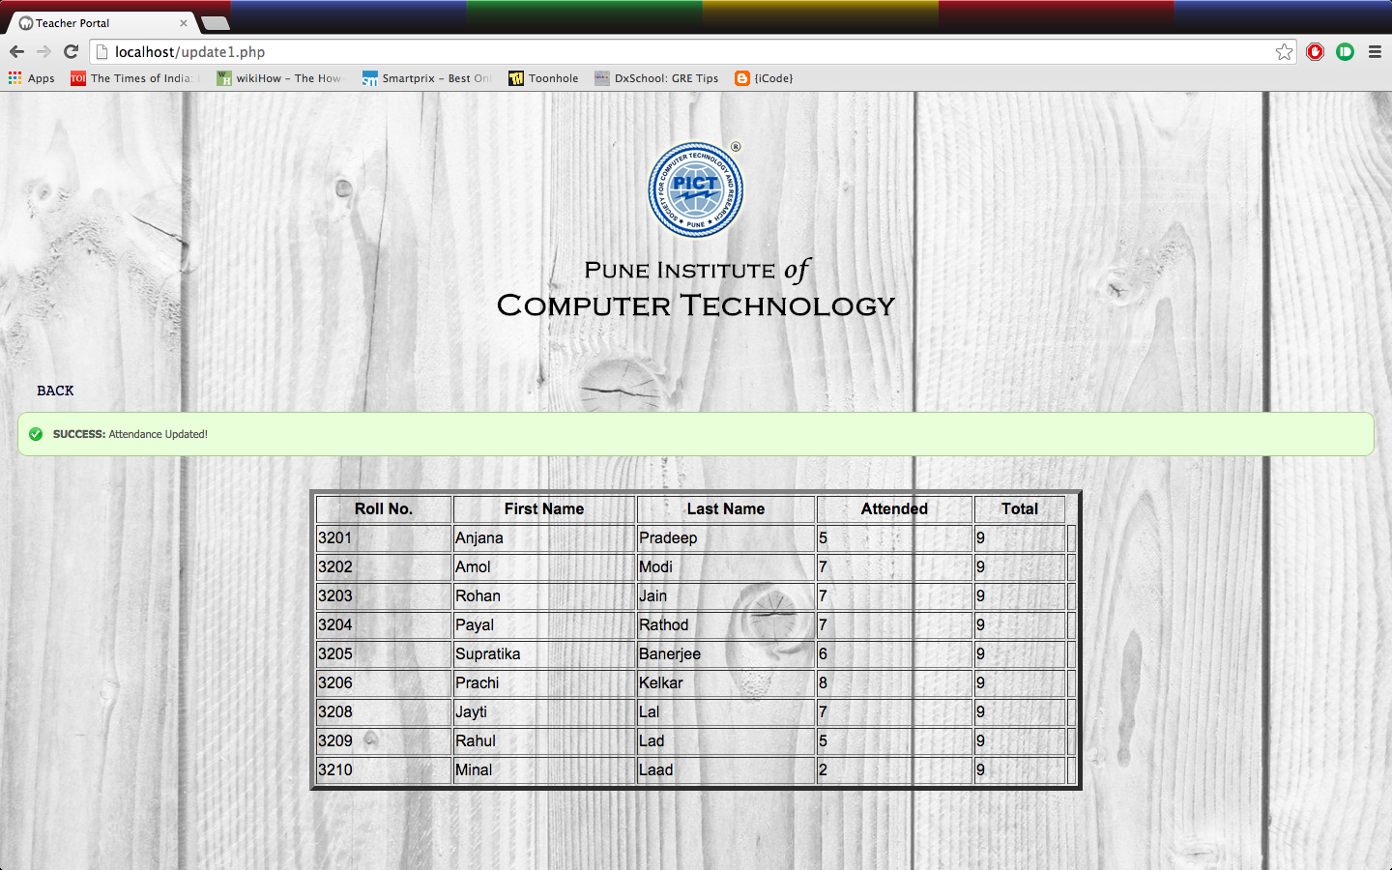

3.3 Process Leave

Using the button Student Leave Application on the page after Teacher Login the supervisor can grant, decline the leave on account of the student’s attendance. To grant the leave, check the checkbox in front of the application of the applicant otherwise leave it uncheck to deny the leave and press the Submit button.

On approval/denial the applicant will be notified on his/her account.

**See the screenshot below**

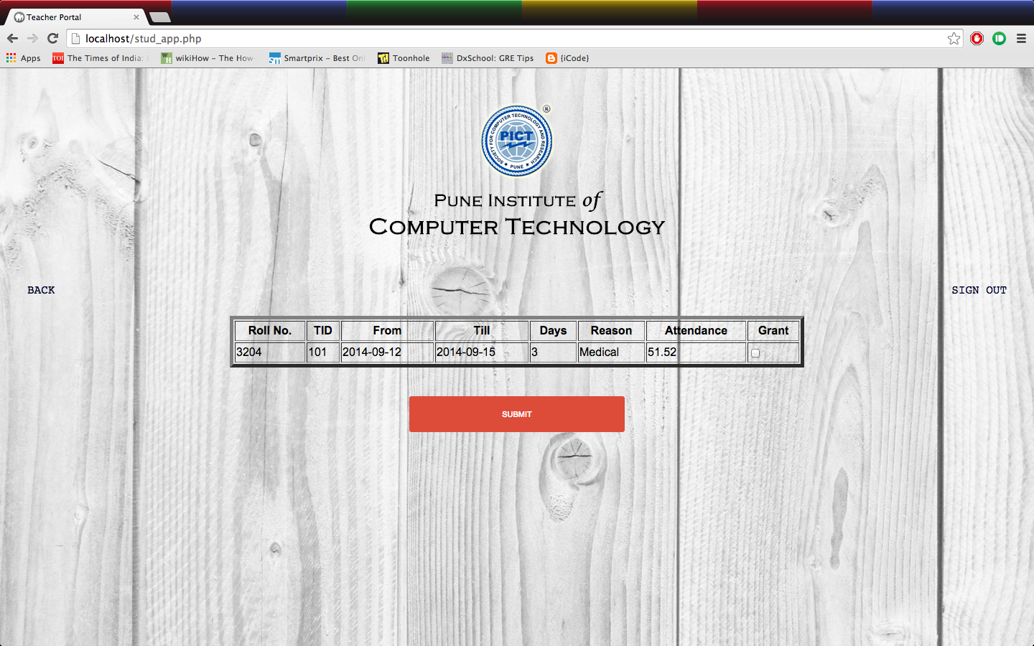

1 Check for Leave Application Status

After successful login by the student, click on the Button Leave Status to check whether the leave has been granted or denied. Student can now apply for another leave application if he/she wishes.

**See the screenshot below**

